Albany Ride for Missing Children
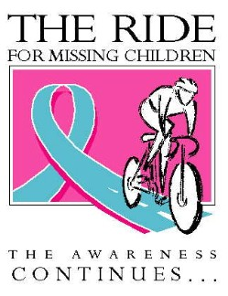

Donor Pledge Form
Rider’s Name Address _ Email Phone Date

Donor Name/email | Address | City/ State/Zip | (x) if NO tax letter required | Donation Amount | Check#
John Doe jdoe@rochester.rr.com | 275 Lake Ave. | Rochester NY 14608 |  | $00.00
1.
email.
2.
email
3.
email
4.
email
5.
email
6.
email
7.
email
8.
email
 |  |  | TOTAL
All checks should be made payable to NCMEC/NY
Please return this form with your pledges prior to September 20, 2019 to Jen Fitzpatricke ** 6 John Streete ** Cohoes, NY 12407
NO ACKNOWLEDGEMENT WILL BE SENT OUT WITHOUT FULL NAME AND ADDRESS

NCMEC is a 501(c)(3) tax-exempt charity and is a publicly supported organization as defined in sections 509(a)(1) and 170(b)(1)(A)(vi) of the Internal Revenue Service Code. Our Federal identification number is 52- 1328557. Proceeds from this event will be used to fund NCMEC/NY’s prevention education programs and support the Branch mission. For more information about NCMEC/NY call 585-242-0900.

